Rudik V.A.
Orlova K.S.
Simchenko S.V.
Davydov O.V.
Pylypenko I.O.

REPORT ON EFFICIENCY OF ANTI-MOSQUITO DEVICES: CATCHING BLOOD-SUCKING MOSQUITOES IN DELTA OF THE DNIEPER RIVER
Studies were conducted in the delta of the Dnieper river, the southeast from the city of Kherson, on a dry land between 1st and 2nd creek (46 ° 37'25.09 "C; 32 ° 37'29.67" B) 03.09.2018 - 06.09. 2018 (Fig. 1).

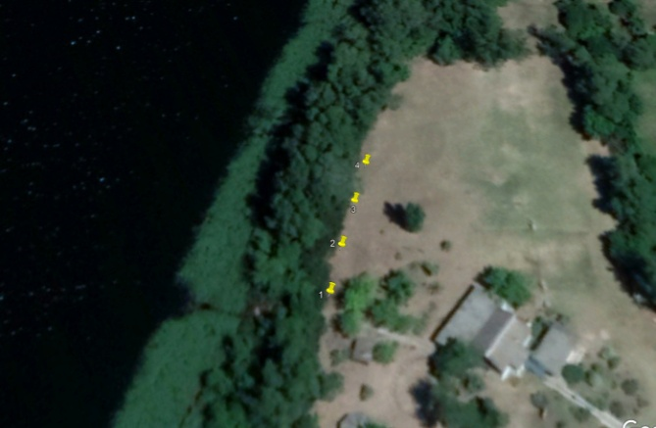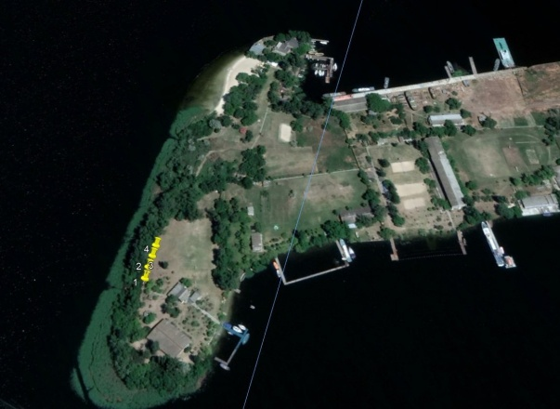
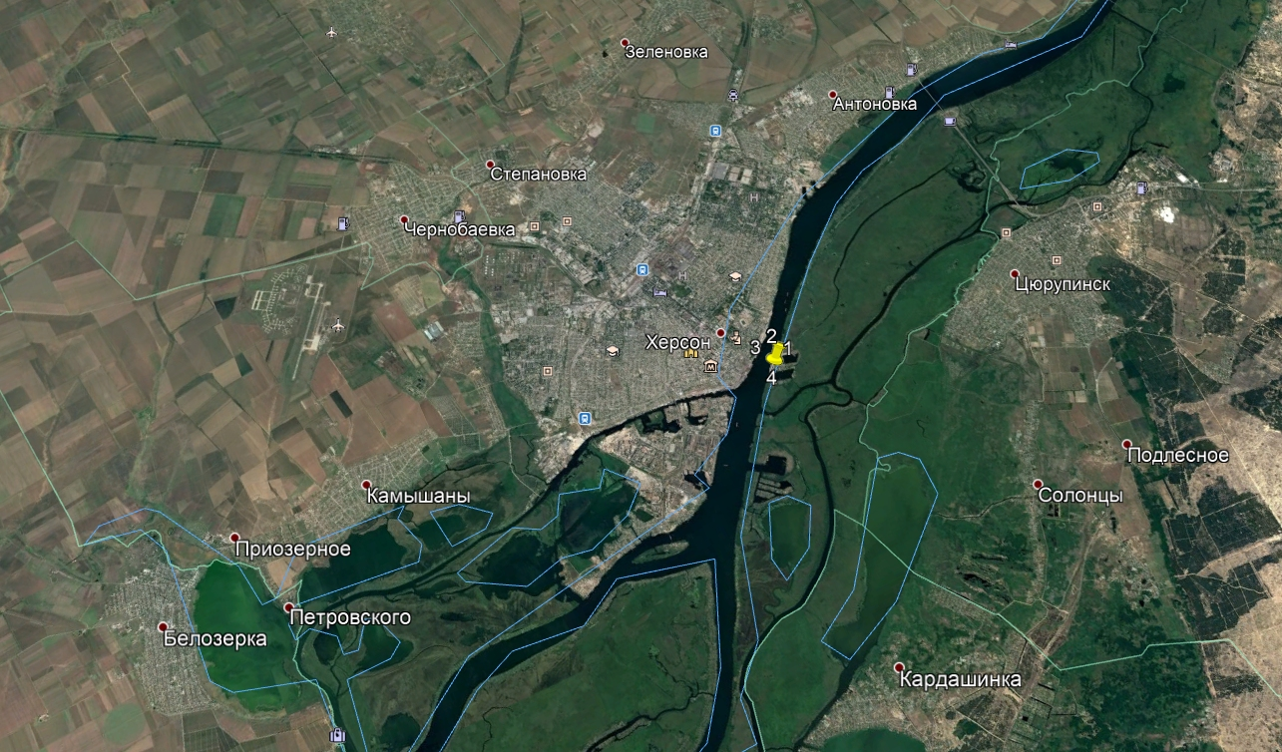
Fig.1. Localities of setting traps. Scaling.

Mosquito catching devices were placed along the floodplain forest belt (spacing 0.5 m from the edge) with a linear interval of 5 m (Fig. 2). The numbering of the traps is from left to right (Fig. 3).

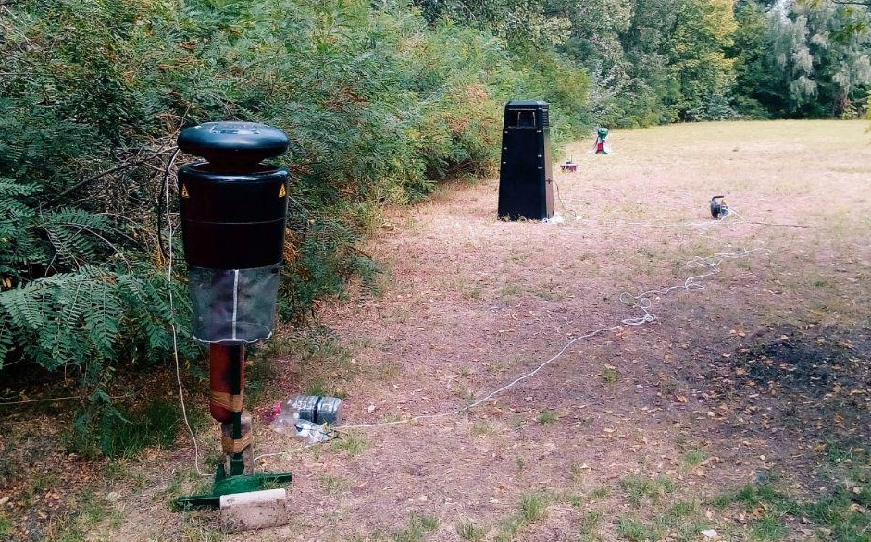
Fig. 2. Placement of devices along the floodplain forest belt every 5 meters.
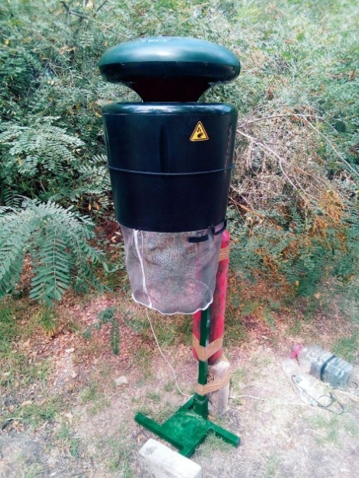1 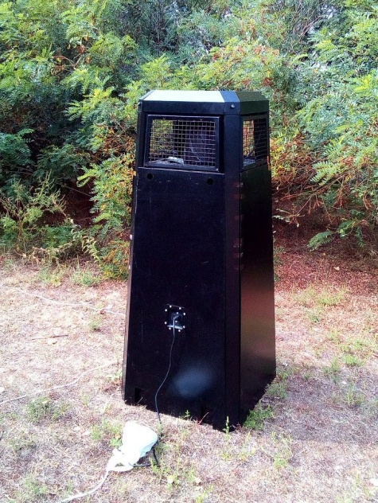2 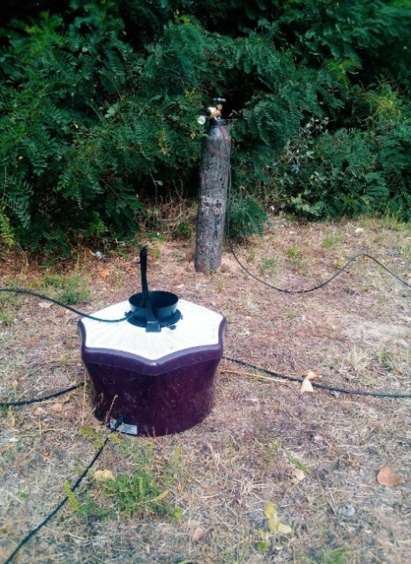3 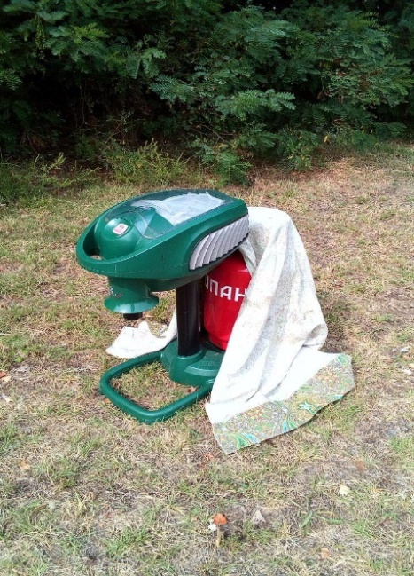4
Fig. 3. Device numbering.
The material was collected 2 times a day: at 7 a.m. (the species of insects were registered in the evening, at night and in the morning) and at 7 p.m. (species, active during the daytime). Various species of insects were trapped. CULICIDAE family accounting was conducted. The collection of the material at 7 a.m. was the most revealing in the qualitative and quantitative composition - evening, night and morning catches namely. Morning catches were collected 3 times: 04.09.2018, 05.09.2018, 06.09.2018. The diagrams show the relative (Figure 4) and quantitative (Figure 5) values ​​of the captured blood-sucking mosquito species (DIPTERA: CULICIDE).

Fig. 4. Relative value of samples in percentage.

Fig. 5. Quantitative value of mosquitoes caught.

The devices caught 1356 mosquitoes in 3 nights (Fig. 6). Most notably:
Device #1 63 mosquitoes;
Device #2 565 mosquitoes;
Device #3 286 mosquitoes;
Device # 4 442 mosquitoes.

Fig. 6. Comparative indicators of trapping blood-sucking mosquitoes.
Sampling in the evening (7 p.m.) was insignificant. During 36 hours of the day, 9 blood sucking mosquitoes were caught. Of these, 7 mosquitoes were caught by Device #4, 1 mosquito by Device #2, 1 mosquito by Device #3.

Species composition of mosquitoes captured is heterogeneous, represented by 5 species:

Family CULICIDAE:
Subfamily CULICINAE:

Tribe Mansoniini
Genus Coquillettidia Dyar, 1905
Subgenus Coquillettidia Dyar, 1905
- Species Coquillettidia richiardii Ficalbi, 1889
Tribe Aedini
Genus Aedes Meigen, 1818
Subgenus Aedes Meigen, 1818
- Species Aedes vexans Meigen, 1830
Tribe Culisetini
Genus Culiseta Felt, 1904
Subgenus Culiseta Felt, 1904
- Species Culiseta annulata Schrank, 1776

Subfamily ANOPHELINAE:

Genus Anopheles Meigen, 1818
Subgenu Anopheles Meigen, 1818
- Species Anopheles hyrcanus Pallas, 1771

- Species Anopheles maculipennis. Most probable Anopheles messeae Falleroni, 1926 (typical and massive species of the genus for the floodplain, inferior in number - in August-September - only to A. hyrcanus).

In the quantitative ratio, the species captured are represented (Figure 7) as follows:

Aedes vexans– 289 specimens (21,3%)
Coquillettidia richiardii – 636 specimens (47%)
Culiseta annulata – 69 specimens (5,1%)
Anopheles hyrcanus – 304 specimens (22,3%)
Anopheles maculipennis – 58 specimens (4,3%)

Fig. 7. Ratio of species caught during the study period
Coquillettidia richiardii is numerous. Aedes vexans and Anopheles hyrcanus species in a quantity ratio take equal positions and, collectively, their quantity approximately corresponds to Coquillettidia richiardii.

Conclusion
1. During the study 03/09/2018 - 06/09/2018, 1356 blood-sucking mosquitoes were caught with the help of 4 devices.
2. According to the number of blood-sucking mosquitoes caught, the most effective is the device # 2 - 565 mosquitoes. The second place in terms of effective capture, takes device # 4 - 442 mosquitoes. The third place belongs to the device # 3 - 286 mosquitoes.
3. Mass catching of blood-sucking mosquitoes and other species of winged insects makes it possible to use the trapping device (# 2) in places of mass congestion to protect against mosquito attack.
4. Mass catch makes it possible to use trapping devices for scientific research.

Notes and recommendations
1. When sampling at 7 p.m. on 04/09/2018, there was no CO2 gas found in the cylinder of trap # 2, which resulted in an insignificant number of mosquitoes captured. For technical reasons, the restoration of the supply of carbon dioxide was held at 7 p.m. on 05/09/2018.
2. UV lamp worked one night from 03/09/2018 to 04/09/2018. This night, the largest number of flying insects was caught, including blood-sucking mosquitoes (828 mosquitoes). The percentage of mosquitoes in the total biomass of 7 a.m. sampling on 04/09/2018 was small. During 7 p.m. sampling on 04/09/2018, the lamp was turned off to reduce the impact of attracting non-bloodsucking insects. At night on 05/09/2018 and 06/09/2018 the lamp was off. These actions led to a significant decrease in the number of associated species in the sample (Figures 8, 9). If we take into account the number of mosquitoes, caught by devices each night, so the dynamics of the decrease in the number of mosquitoes is evident (all traps: 04.09 - 828 mosquitoes, 05.09 - 192, 06.09 - 336) Trap # 2: 04.09 - 361; 05.09 - 16; 06.09 - 188 mosquitoes). As a result of UV lamp operation only on 04.09, it would be possible to assume that the lamp had a significant impact on the statistically most massive catch. For all the traps. And its further disconnection led to a general reduction of mosquitoes captured, as well as reduction of accompanying species in the distance of 5 meters linearly. However, if we take into account the weather conditions during the course of the study, it becomes obvious that the impact of heavy rainfalls on the number of objects in the samples. When sampling was carried out at 7 p.m. on 05/09/2018, the device #2 was modernized to attract insects with heat (a heating layer was used (Figure 10)), allowing to catch a practically clean sample of 188 blood-sucking mosquitoes at 7 a.m. on 06/09/2018, which accounted for 56% of all night catch by all traps in the conditions of rain. Compared with 7 a.m. sampling on 04/09/2018 with the UV lamp on, 361 insects, 43.6% in the absence of precipitation.

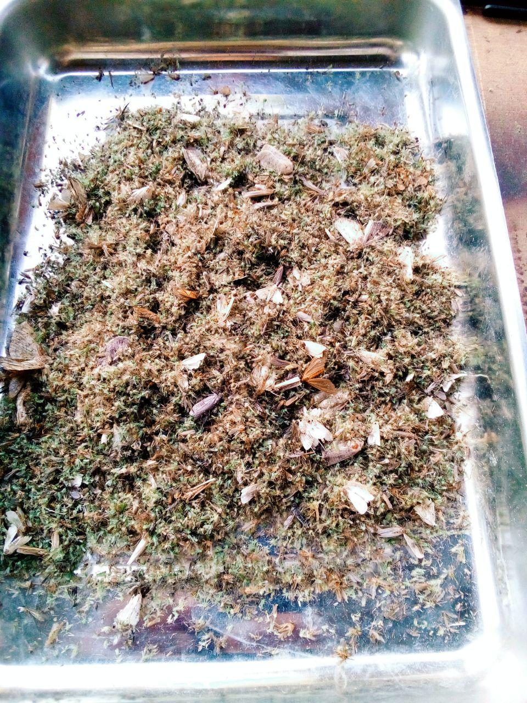
Fig. 8. 7 a.m. sampling on 04.09.2018 with UV lamp on.

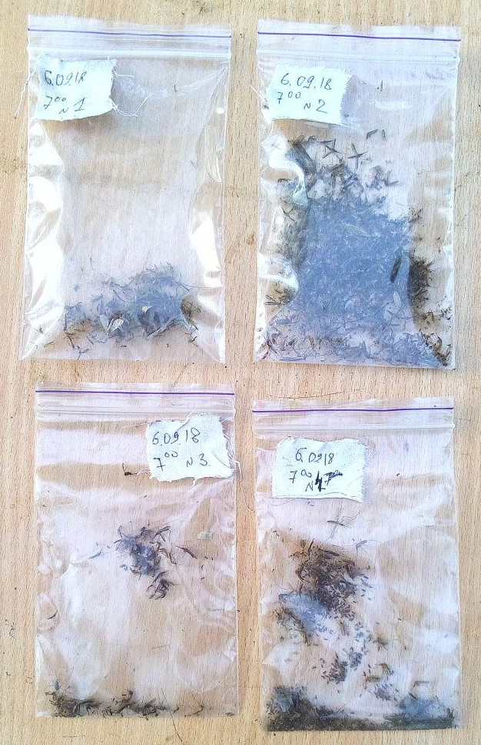
Fig. 9. 7 a.m. sampling on 06.09.2018 with UV lamp off.
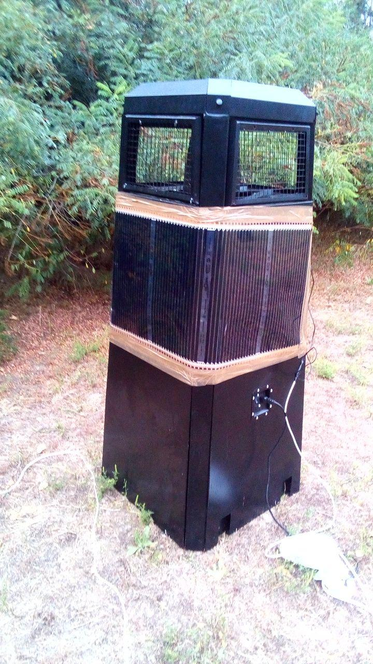
Fig. 10. Modernization of device #2 for heating effect.

